**Requirements for the development of POP DASHBOARDS**

# EXP&LOG DASHBOARD

* Data will be display into a MAP
* For the DATA to be used by the MAP we can use the query existing in ICON MAP plus other fields highligted below:
  + Projects with different icon between Solar, wind, Storage and color different if Exp&Log status Completed or ongoing
  + Factories associated with mr
  + Associated ports in the DP
  + Name of the vessel icon for the vessel in transit
* **Exp&Log Progress**
  + displays the list of main contractors and calculates for each the total progress % of all the competitors.
  + Allows you to see the progress detail for each sub-item/Sub-supplier
  + Ability to extract tables in excel

|  |  |  |  |  |  |
| --- | --- | --- | --- | --- | --- |
| Main Contractor | WBS Level | FAT % | Shipped % | Custom % | On site % |
| Vestas |  |  |  |  |  |
| CHint |  |  |  |  |  |

|  |  |  |  |  |  |  |  |  |
| --- | --- | --- | --- | --- | --- | --- | --- | --- |
| Item | Sub-item | Sub-supplier | Quantity (MR) | Quantity  (DP) | FAT % | Shipped % | Custom % | On site % |
| Nacelle | Nacelle assembled | Vestas |  | 10 | 0 | 50 | 20 |  |
| Blade | Blade set | Vestas |  | 10 |  |  |  |  |
| Tower | T1 | Tpi |  | 10 |  |  |  |  |

**Progress rule**: I calculate the % achieved on the basis of the dates with respect to the total Q. If the dates are missing, I adjust the previous progress to the next step.

* FAT %: QTY MR and FAT Date
* SHIPPED%: QTY DP and Exwork data
* CUSTOM %: QTY DP e data Custom
* ON SITE % QTY DP and Data DOS finish ahead
* N° Factories
* N° Main contractor
* N° sub-supplier
* **Delays monitoring:** report the delay tiles of the critical dashboard
* **Schedule Reliability of the project of the shipments:** % delay of the project shipments (arrivals on site, with local and abroad detail.
* **Manufacturing Project Schedule Reliability:** % Manufacturing Delay

1. **EXPEDITING DASHBOARD (cap 5.1.1 TS)**

To be included in a section dedicated to dashboards

* N° of activities for each type; (EXP; FAT; FI...) to be taken from the inspection recording file. Resources involved: internal or external; possibility to filter by technology and by region (Factory or Project).
* The graph must be able to show in which quarter of the year the activity was carried out.

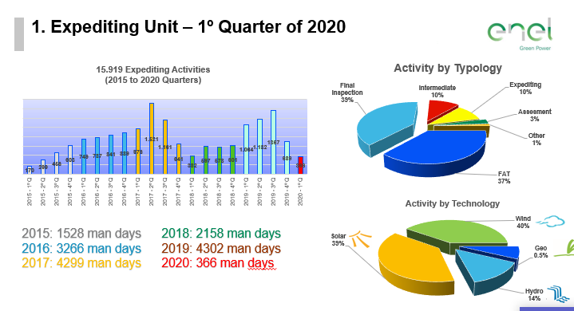

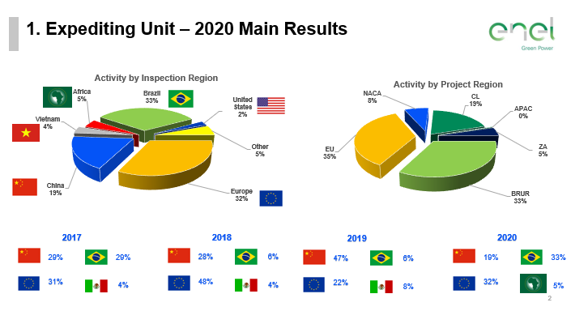

* MONTHLY REPORT (requirement required in TS 5.7) – source of inspection log data: monthly report is updated representing a list of activities managed by each team and by the individual Expediting Specialist highlighting the activities for which some information to be provided is pending. Trend activity from month to month should be monitored. Below example of selectable dashboard filters

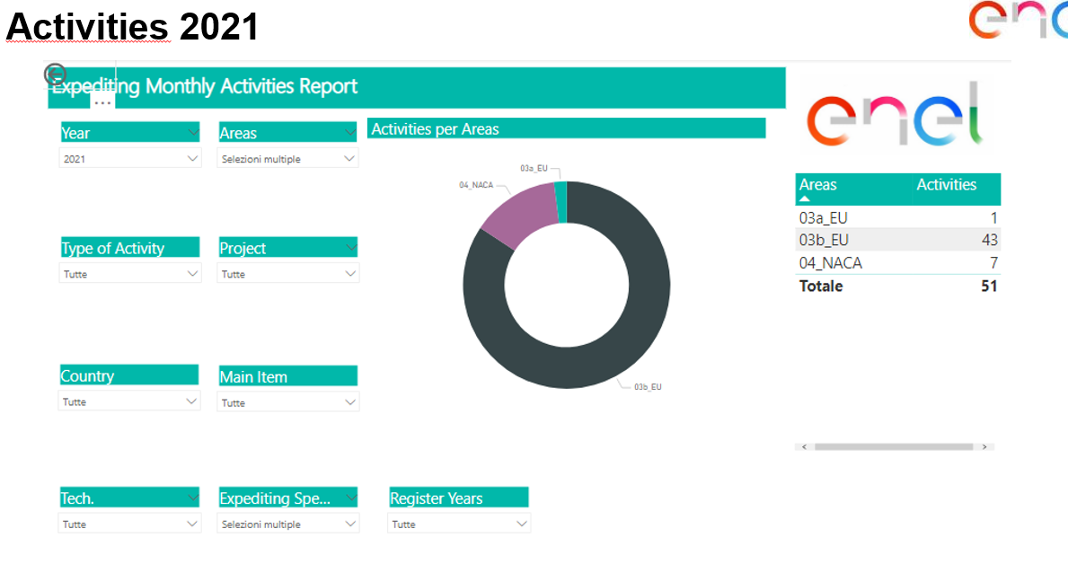

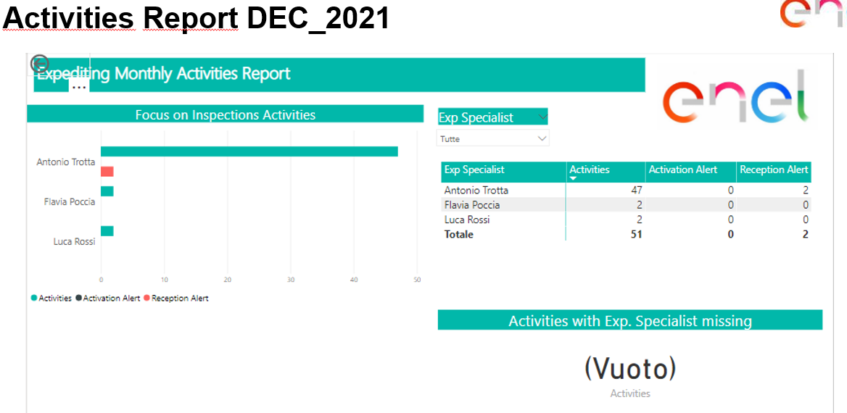

1. **BUDGET DASHBOARD (cap 5.1.1 TS)**

must display:

* the "Assumption book" budget (obtained from the badget tool – to be implemented)
* budget approved to Project (manually entered by ExpS)
* budget from Expediting Plan (automatically calculated in POP)
* final budget (calculated by the inspection contract management section)

1. **INSPECTION BODIES DASHBOARD (TS 5.6)** – data source contract management section

ThePlatform must ensure the correct management and monitoring of its contractual details:

1. Duration of the contract;
2. Amount/budget of the contract, together with the accounting management of the services entrusted;
3. Analysis (quantity and type) of the activities assigned and carried out;
4. **FACTORY ASSESSMENT DASHBOARD(TS 5.5):**
   * graphical representation of FAs performed by filtering by Country / Item / Main Contractor / year of execution and expiration date
   * Possibility to choose different FAs from different factories to be able to compare the scores (total and individual checklists) highlighting any "expired" FAs
   * Tabular representation of FA executed – Score – Expired/Valid (with the possibility of filtering by Country/Item/Main Contractor)
5. **LOGISTICS DASHBOARD (TS Chap. 8)**

The dashboard must contain filters: project, AC, Project Country, Tech, Item, Exp&Log status

* **Shipment tracking:**
  + **N° containers delivered on site** (rules already implemented for APIs)
  + **N° oversize components delivered on site** (rules already implemented for APIs)
  + **N° batch/ shipment** (DP line) **delivered on site**
  + **N° shipping delivered**
  + **N° shipments in progress** (evaluated by check on exworks dates and arrival at the finish forecast site)
  + **Next shipments in the prox 2 week:** check on exwork and delivery on site, with distinction of naval shipments
  + **Used Shipping Routes:** from POL to POD
* **Schedule Reliability Global:**

**---------**

**Extraction for each project – to be inserted in the project workspace:**

* Only for SOLAR project and for item PV MODULE create a report extractable in excel "**Containers delivery at site**" (eg. SPAIN file)

